EXP 31: Web Blog Using WordPress

Aim
To create a web blog using WordPress and demonstrate HTML elements such as the title tag, anchor tag, heading tag, and paragraph tag.

Algorithm
- Start.
- Open WordPress and create a new blog website.
- Select a suitable theme.
- Create a blog post with a title, headings, and paragraph.
- Add a hyperlink using the anchor tag.
- Publish and view the blog.
- Stop.

Code
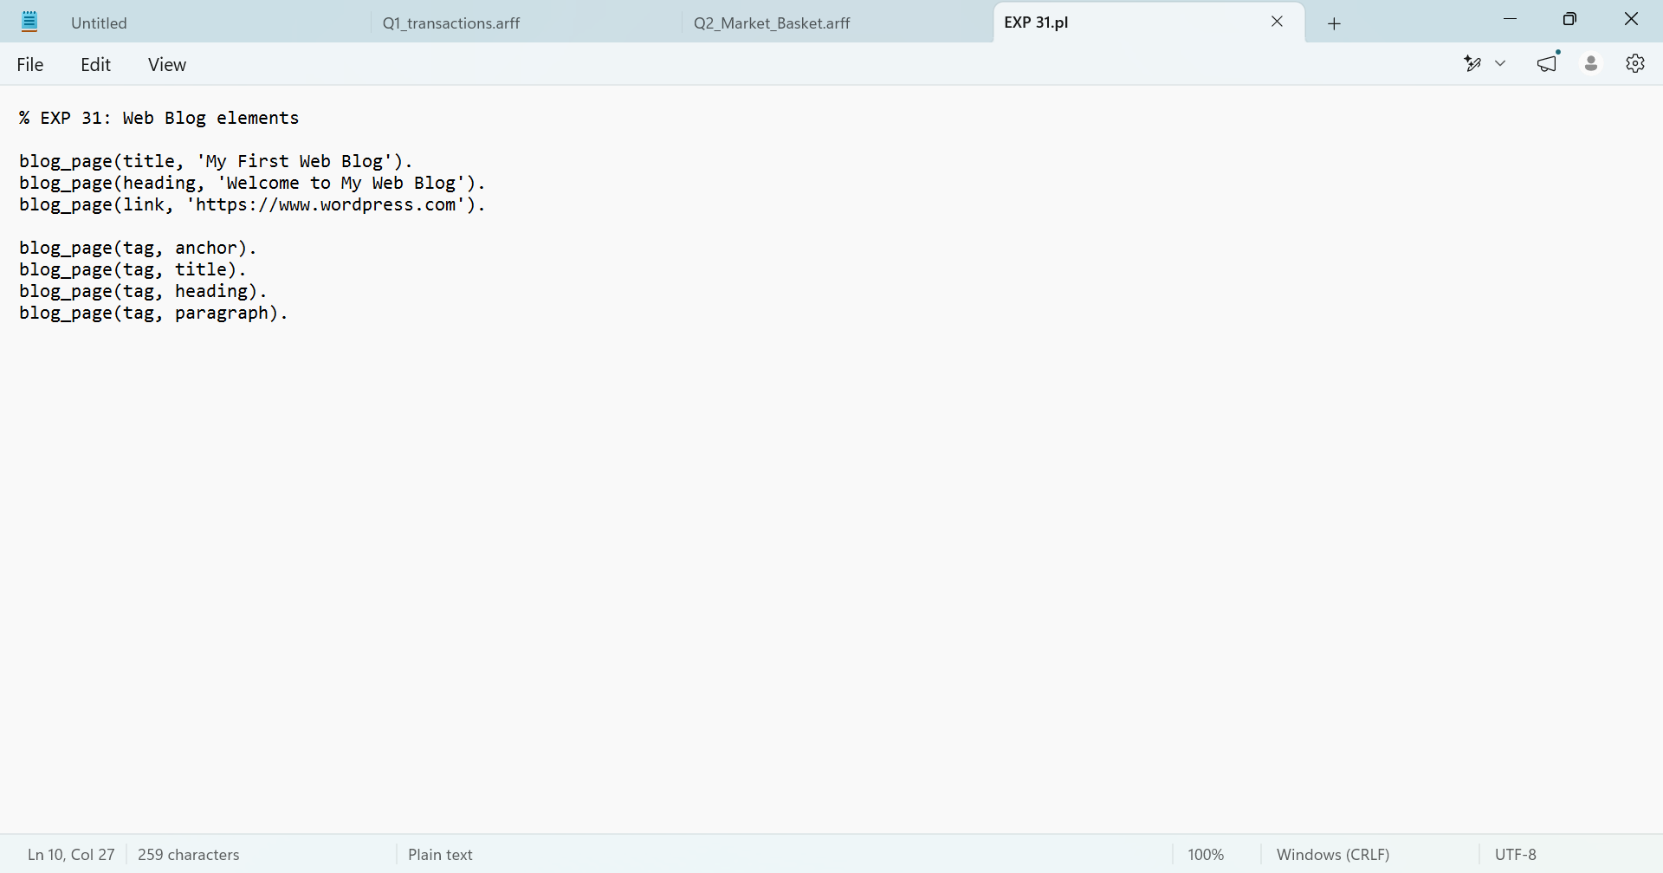

Output
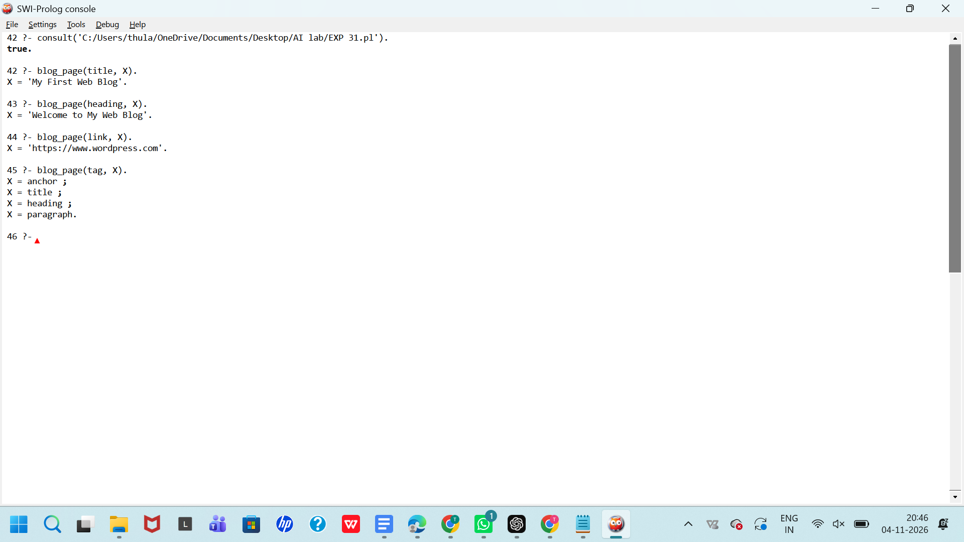

Result:
Thus, the Prolog program for representing web blog elements was successfully implemented and executed. The required queries were tested to retrieve the blog title, heading, hyperlink, and HTML tags.

EXP 32: Pattern Matching in Prolog

Aim
To write and execute a Prolog program to implement pattern matching using facts and rules.

Algorithm
- Start.
- Define patterns and their corresponding responses.
- Create a predicate to match a given pattern.
- Query the predicate with different patterns.
- Display the matching responses.
- Stop.
Code
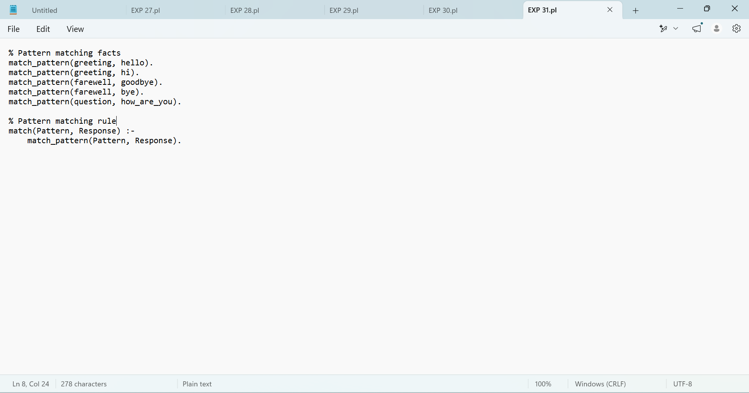

Output
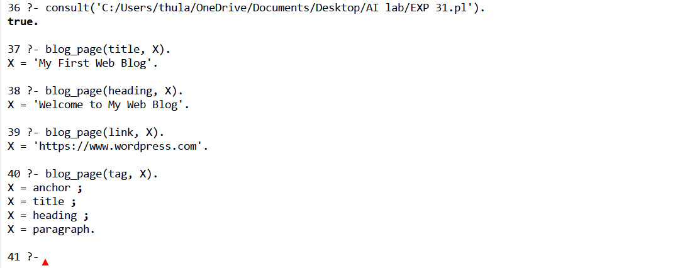

Result
Thus, the Prolog program for pattern matching was successfully implemented and executed. The required queries were tested and returned the corresponding matching responses.

EXP 33: Count the Number of Vowels in a String Using Prolog

Aim
To write and execute a Prolog program to count the number of vowels in a given string.

Algorithm
- Start.
- Define the vowels.
- Read a string and convert it into a list of characters.
- Check each character to determine whether it is a vowel.
- Count the vowels recursively.
- Display the total number of vowels.
- Stop.
Code
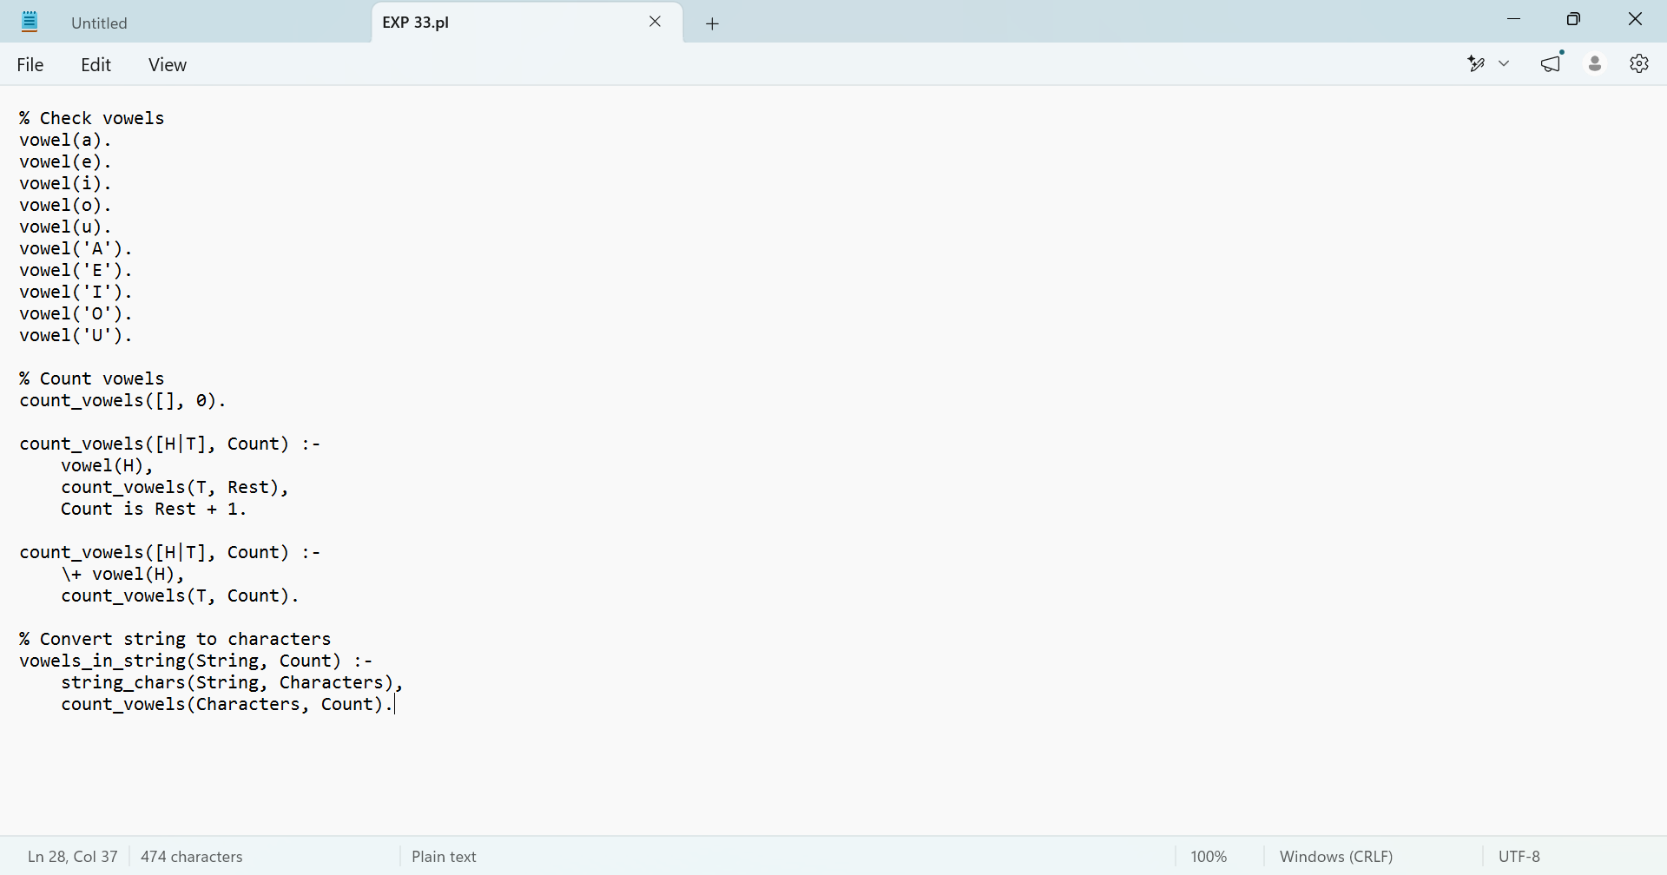

Output
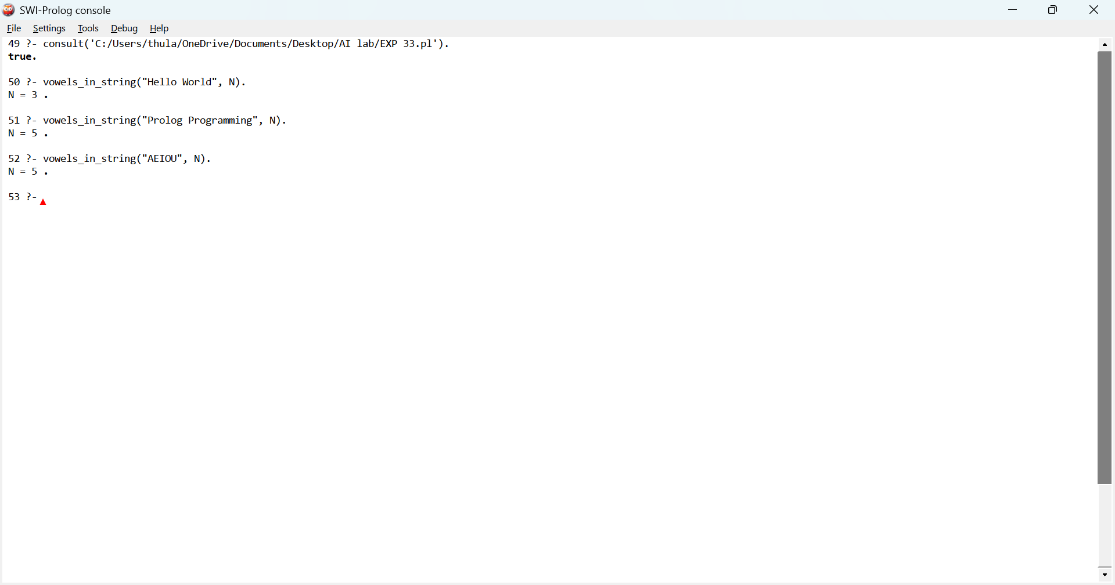

Result
Thus, the Prolog program to count the number of vowels in a given string was successfully implemented and executed.

